**INCOMING MAIL SERVICE**

**Enable POP Access in Gmail**

1. **Log in to Gmail:**
   * Open your Gmail account in a web browser.
2. **Go to Settings:**
   * Click the gear icon in the top-right corner of Gmail.
   * Select **See all settings**.
3. **Navigate to the "Forwarding and POP/IMAP" Tab:**
   * In the settings menu, go to the **Forwarding and POP/IMAP** tab.
4. **Enable POP:**
   * Under the **POP Download** section, select one of the following:
     + Enable POP for all mail (even mail that’s already downloaded).
     + Enable POP for mail that arrives from now on.
   * Optionally, configure how Gmail should handle emails after they are accessed via POP (e.g., "Keep Gmail’s copy in the Inbox").
5. **Save Changes:**
   * Scroll to the bottom of the page and click **Save Changes**.

**Odoo Configuration for Incoming Mail**

**Step 1: Enable CRM/Lead & Custom Email Servers**

* In Odoo settings, check the **CRM/Lead** and **Emails/Use Custom Email Servers** checkboxes.

**Step 2: Generate App Password**

* Use a **two-step verified email** and create an **app password** for authentication.

**Step 3: Navigate to Incoming Mail Servers**

* Go to **Settings > Technical > Email > Incoming Mail Servers**.

**Step 4: Set Up an Incoming Mail Server**

* Click **Create** and provide the following details:
  + **Description:** Name of the mail server (e.g., "IMAP Server").
  + **Server Type:** Choose **IMAP** or **POP** (**Use POP Server**).
  + **Server Name:** Your email provider's server address:
    - **IMAP:** imap.gmail.com
    - **POP:** pop.gmail.com

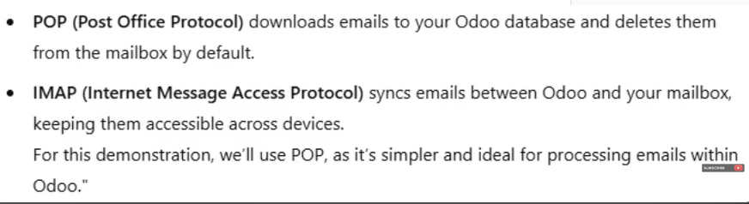

* + **Port:**
    - Typically 993 for IMAP (SSL)
    - **995** for POP3 (SSL)
  + **SSL/TLS:** Select **True**
  + **Username:** Your email address
  + **Password:** App password

**Step 5: Define Actions for Incoming Emails**

* Choose what happens when emails are received:
  + **Create a New Record** (e.g., Lead, Ticket, etc.)

**Step 6: Test Configuration**

* Click **Test & Confirm** to verify the setup.

**Step 7 (Optional): Add Company to Database**

* Go to **Contacts > Companies**.
* Create a new company record and populate the **Email Domain** field (e.g., **@gmail.com**).

**OUTGOING MAIL SERVICE**

**Purpose of Outgoing Emails in Odoo**

Outgoing emails are used for sending:

* Notifications
* Invoices
* Marketing emails

**Steps to Configure Outgoing Mail Server**

**Step 1: Enable Email Feature**

* Navigate to **Settings > General Settings**.
* Ensure the **Email** feature is enabled.

**Step 2: Set Up an Outgoing Mail Server**

* Go to **Settings > Technical > Email > Outgoing Mail Servers**.
* Click **Create** and enter the following details:
  + **Description:** Name of the mail server (e.g., "SMTP Server").
  + **FROM Filtering:** Leave empty.
  + **Authenticate with:** Username
  + **SMTP Port:**
    - 587 for TLS
    - **465** for SSL (**Use SSL/TLS**)
  + **Debugging:** Set to **True**
  + **SMTP Server:** smtp.gmail.com (for Gmail)
  + **Username:** Your email address
  + **Password:** App password

**Step 3: Test Configuration**

* Click **Test Connection** to verify the setup.
* If successful, Odoo will confirm the connection.

**Step 4: Set Default Outgoing Server**

* Mark the desired mail server as the **Default Outgoing Server** by selecting the checkbox.

**References:**

* Video Guides:
  + V17: [Watch Here](https://youtu.be/yos0DnLa5XQ?si=T-Dwhr9ro-1JRyyJ)
  + V18: [Watch Here](https://youtu.be/UZIgBTOXDJA?si=nXaicBagsX1YxomE)